Name: shalini Balusamy

Course: JFSD7WD

Task No : 4

Question: 1

Ramesh is developing a student management system for a university. In this system, you have a Student class to represent student information. You are asked to help Ramesh to handle exception which can be occurred into program according to following Scenarios:

⚫ class Student with attributes roll no, name, age and course. Initialize values through parameterized constructor.

• If the age of the student is not between 15 and 21 then generate a user-defined exception "AgeNotWithinRangeException".

If a name contains numbers or special symbols, raise exception "NameNotValidException". Define the two exception classes.

Class: AgeNotWithinRangeException

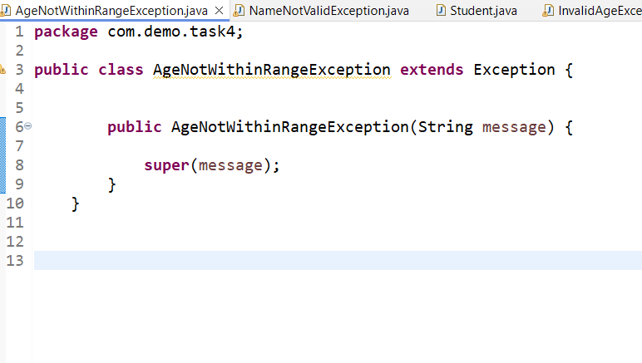

Class : NameNotValidException

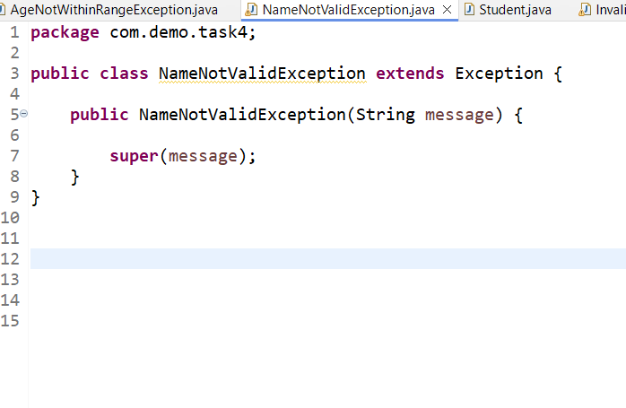

Class : Student

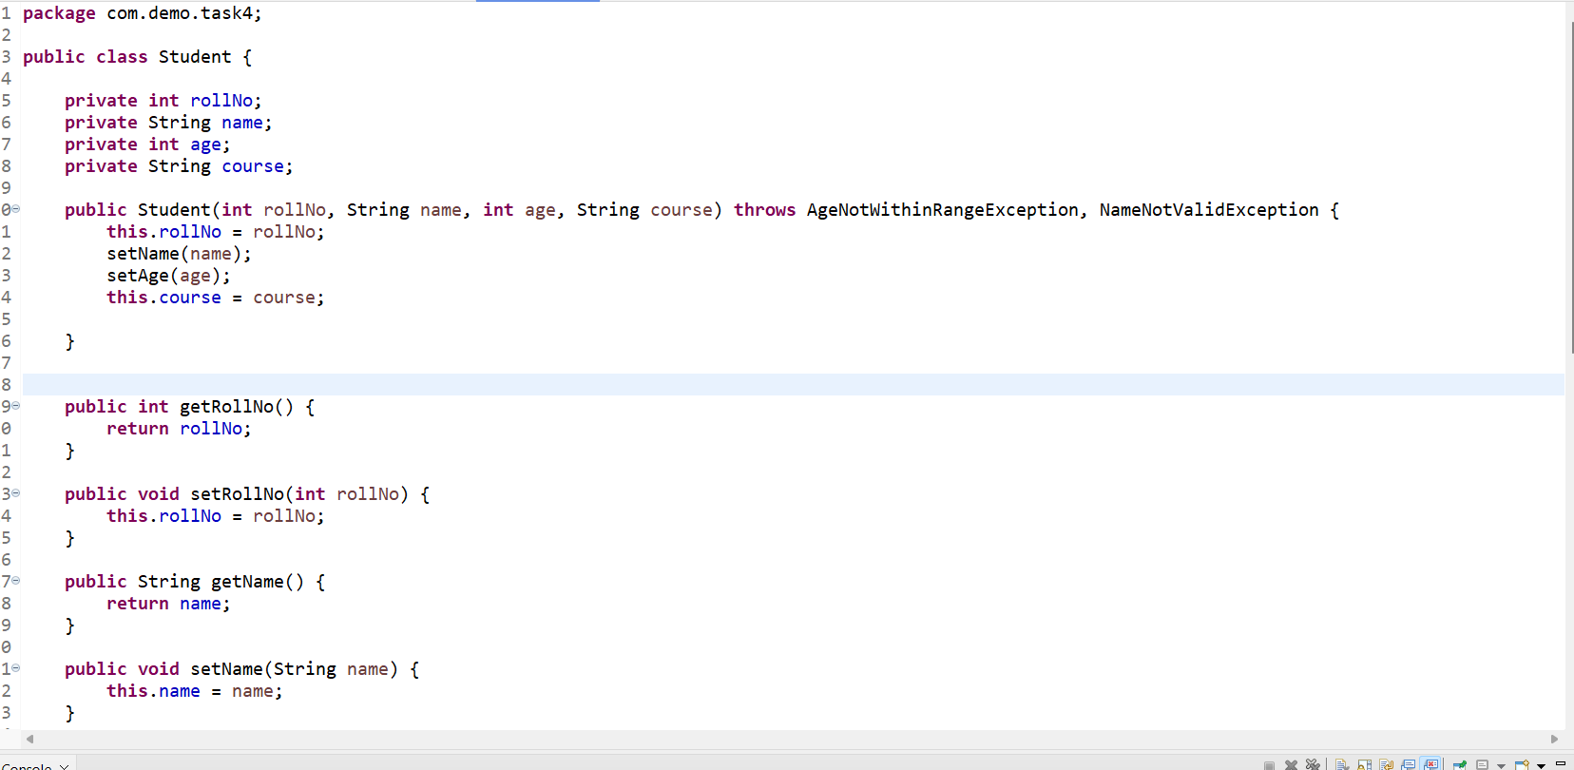

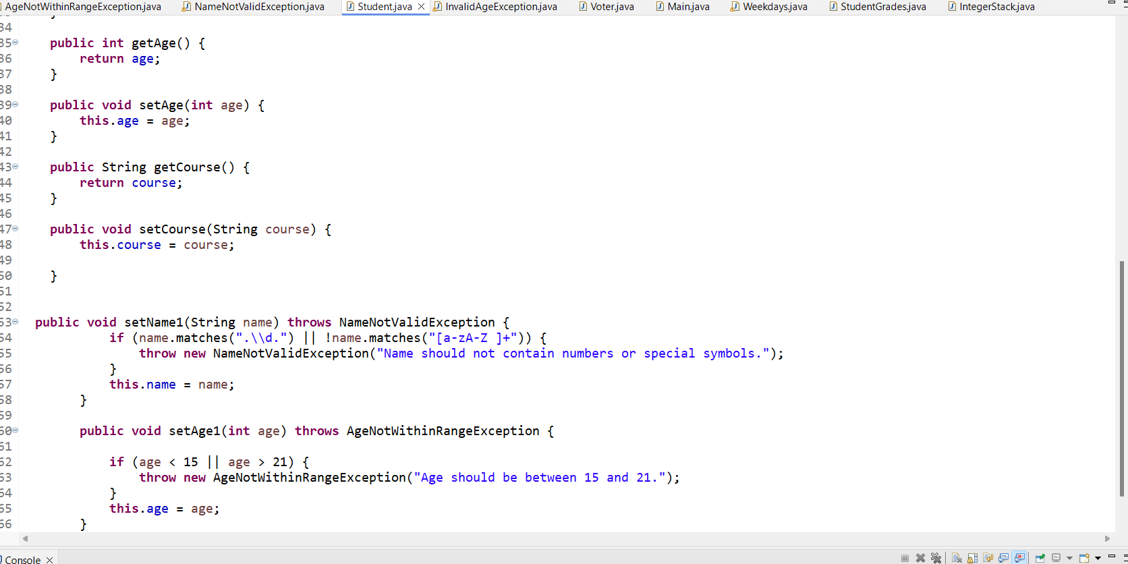

Output:

Question 2: Create a class Voter(voterId, name, age) with parameterized constructor. The parameterized constructor should throw a checked exception if age is less than 18. The message of exception is "invalid age for voter"

Class: Voter

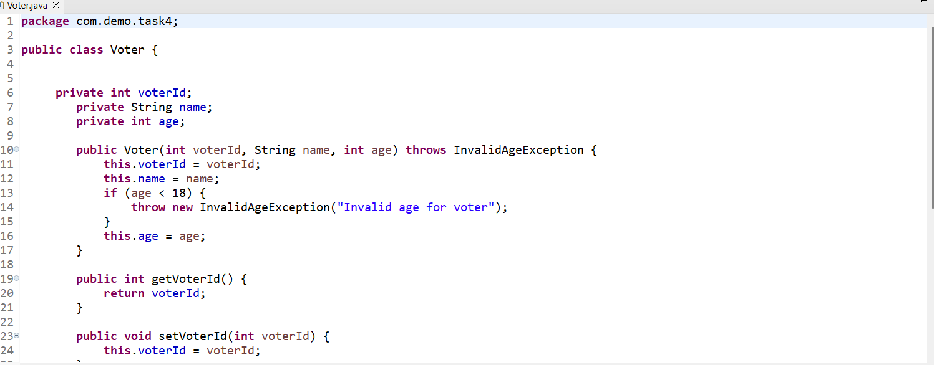

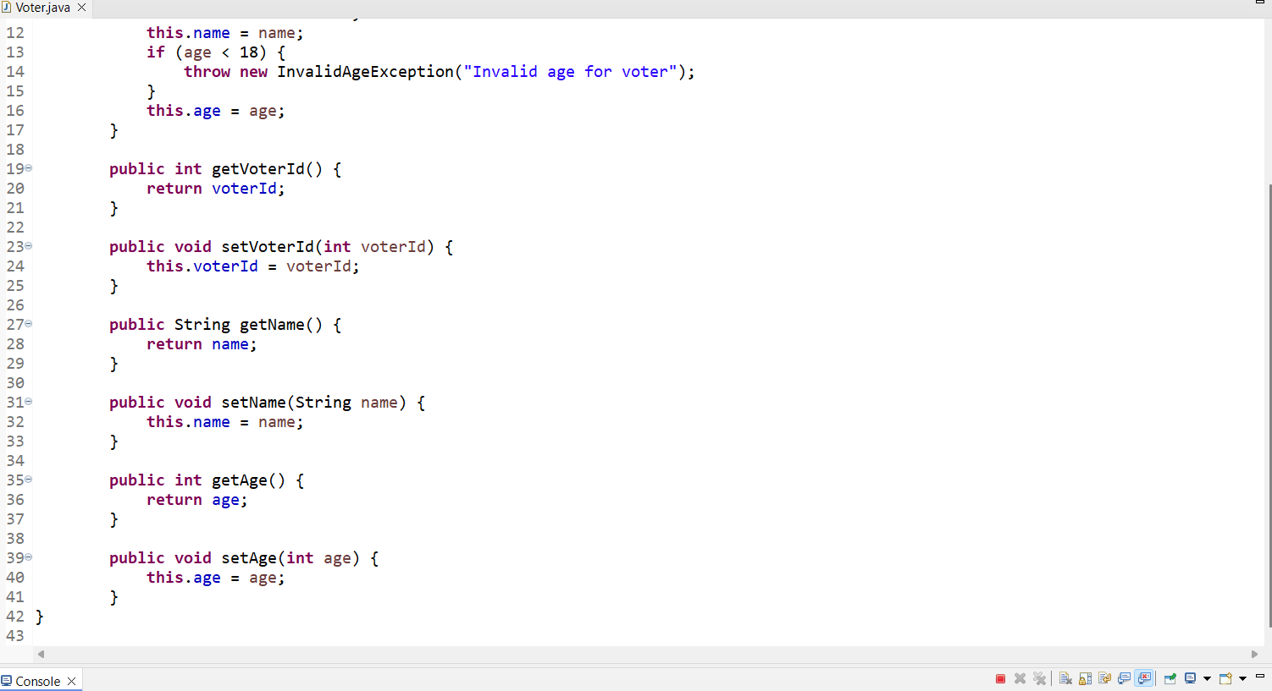

Class Main

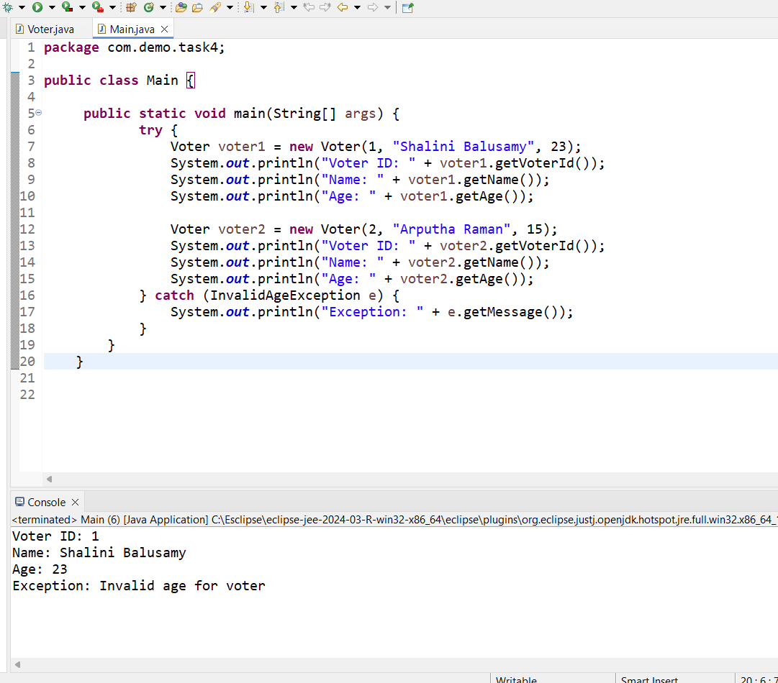

Question 3:

Store name of weekdays in an array (starting from "Sunday" at 0 index). Ask day position from user and print day name. Handle array index out of bound exception and give proper message if user enters day index outside range (0-6).

Class Weekdays

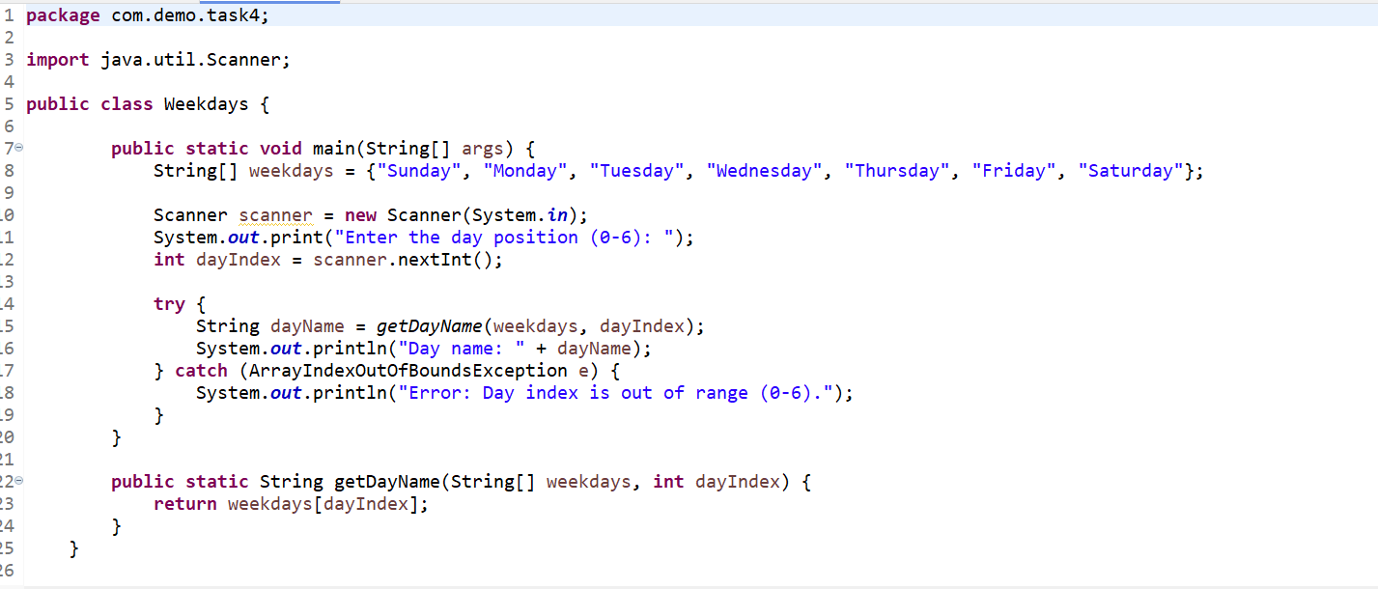

Output:

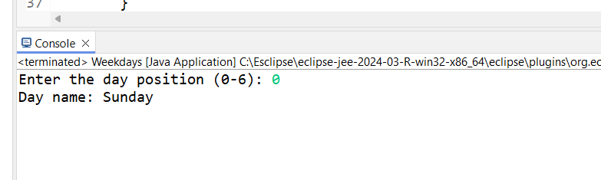

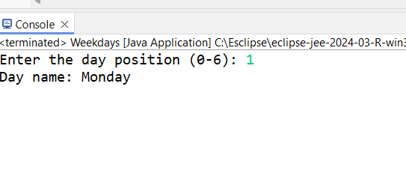

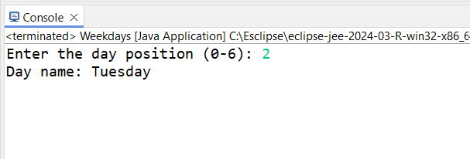

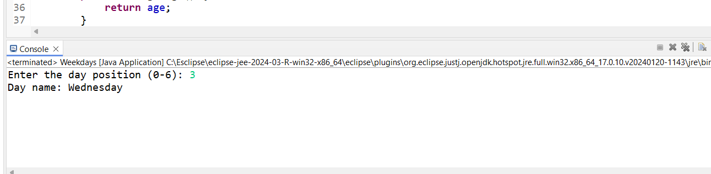

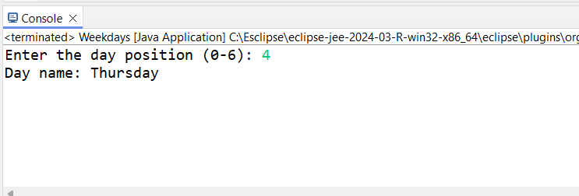

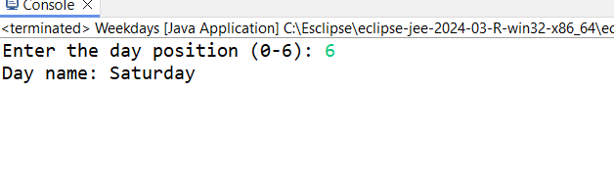

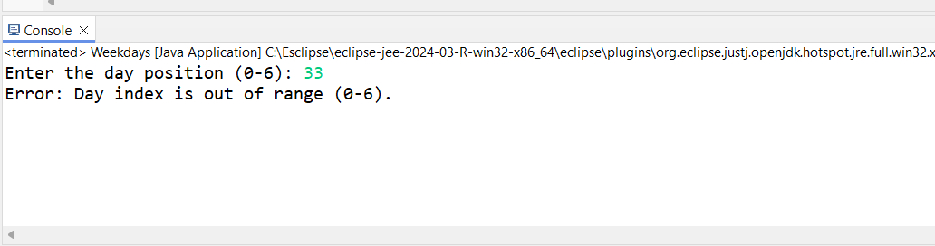

Question 4: Create a HashMap where keys are student names (strings) and values are their corresponding grades (integers). Create methods to add a new student, remove a student, and Display up a student's grade by name.

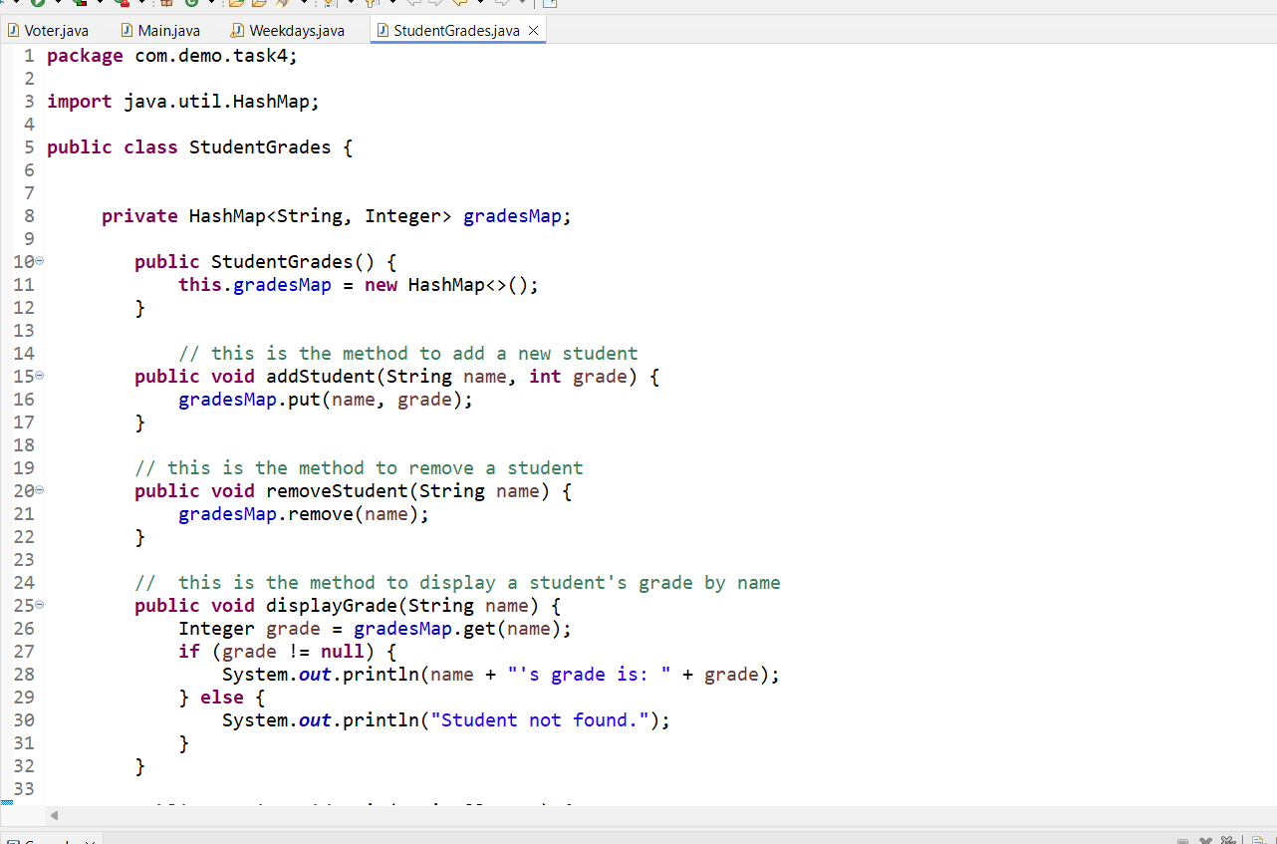

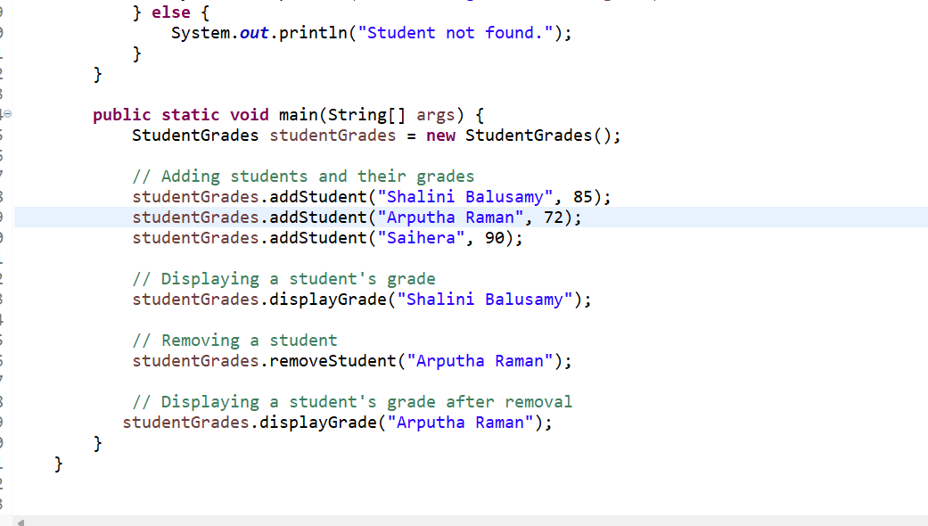

Output:

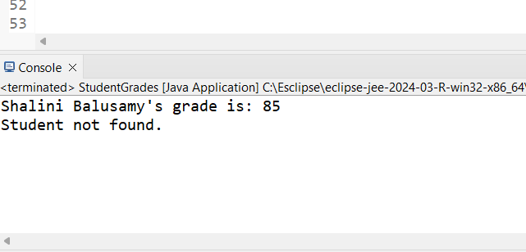

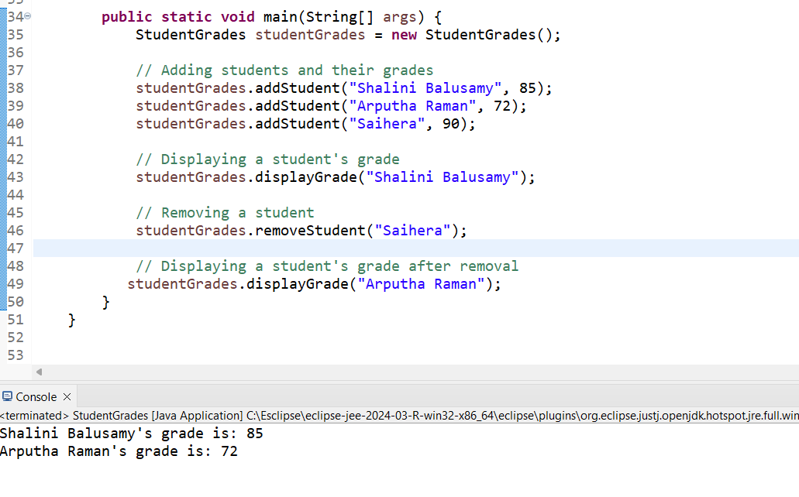

Question 5:

